Milestone 1 Requirements and Use Case Diagram

Team 5

Xiang Liu 12150237

Xujian Zhang 14247952

## Introduction

Selling and purchasing of items can occur every day. It is of high values to create an online market system known as Dbay for Drexel community. Our purpose for this system is to create an environment where people within Drexel community can trade their items conveniently and secured without going through much trouble.

In this milestone 1, our team is working on analyzing all the requirements and possible scenarios for Dbay system. Based on these requirements, we will create a use case diagram.

## Requirements

* Dbay accounts

The very first step for using the Dbay system is to create an account. It is mandatory for every user (including buyer and seller) to create an account on the system. The customer must create an account using their valid Drexel ID and Drexel email, which will be verified through the Drexel Database. Once the account is created, the customer will be provided with the option to update their accounts whenever they want. The seller and the buyer will have an option to manage their inventory that they want to sell, or they want to buy.

* Order processing

There are two options for buyers to purchase items through Dbay system. The first option is to place an order directly, as called “buy-it-now”. The buyers will have an option to update their order if needed. Once the order is placed, the Dbay system will generate an invoice with the order details, payment amount, shipping address, shipping option and sends the invoice to the seller. Once the invoice reached the seller, it becomes the seller’s responsibility to ship the order to the buyer.

Another buying option is to purchase items on Dbay through bidding. The buyer can place a bid for items sold on auction. They can update their bid whenever they want. Once the time duration of the bidding is completed, the system will choose the customer with the highest bid as the winner and the order will be placed. Once the order is placed, an invoice with the order details, payment amount, shipping address, shipping option will be generated by the system and send to the seller.

The buyer has an option to cancel his complete order or part of his order before the order is shipped. If the order is cancelled in time, a cancel invoice will be sent to both the buyer and seller with the details of the cancelled items.

It should be noted that Dbay system does not manage and any inventory or shipping and is not responsible for maintaining inventory and shipping the orders. The seller is fully responsible for these.

* Return processing

Once the buyer receives his order, he can return it within 15 days, if the item is damaged or if he is not comfortable with the items. The return process is initiated by the buyer on the Dbay website. Once a return is initiated, the employee of the Dbay will be responsible from there on to complete the return process. The employee will analyze the return requests and process shipping for the item and notify the return to the seller. Once the return process is completed, the employee will process a refund for the value of the items and deposit it back to the original payment method, such as bank account, debit card or credit card, etc.

* Payment Processing

It is the employee’s duty for handling the processing of payments of all the transactions within the Dbay system. The system only accepts electronic payment methods, such as bank account, debit card, credit card, and dragon dollars. For the bank account, debit card and credit card, the employee will verify the details by contacting the banks or credit card institutions. In addition, the employee is responsible for processing the account of the seller if a return is issued. The dragon dollars will be verified with the Drexel Database System.

* Violation processing

The customers in Dbay system have the option to report if a posted content or item is inappropriate. The Dbay employee is responsible to reviewing these reports, and if verified, the posted content or item will be removed by the employee. Furthermore, Dbay employee has the right to block or ban a customer due to violation of Dbay policies.

## Actors and their interaction with the Dbay system.

|  |  |
| --- | --- |
| Actor | Base Use Cases |
| Buyer | Create Account |
| Place Order |
| Place Bid |
| Cancel Order |
| Request Return |
| Employee | Process Return |
| Process Payment |
| Process Customer reports |
| Process Violation of Dbay policies |
| Seller | Create Account |
| Generate Invoice |
| Cancel Invoice |
| Process Return Item Shipping |
| Bank | Verify Bank Account/Debit/Credit Card |
| Drexel Database System | Verify Dragon Dollars |
| Verify Drexel ID/email |

## Use Cases and Types

|  |  |  |
| --- | --- | --- |
| Case Number | Use Case | Type |
| 1 | Create Account | <<base>> |
| 1.1 | Verify Drexel ID/email | <<included>> |
| 1.a | Update Account Infomation | <<extended>> |
| 1.b | Manage Inventory | <<extended>> |
| 2 | Create Order | <<base>> |
| 2.1 | Place Order | <<included>> |
| 2.2 | Generate Invoice | <<included>> |
| 2.a | Update Order | <<extended>> |
| 3 | Place Bid | <<base>> |
| 3.a | Update Bid | <<extended>> |
| 3.b | Win Auction | <<extended>> |
| 3.1 | Place Order | <<included>> |
| 3.2 | Generate Invoice | <<included>> |
| 4 | Cancel Order | <<base>> |
| 4.1 | Generate Cancel Invoice | <<included>> |
| 5 | Process Return | <<base>> |
| 5.1 | Process Refund | <<included>> |
| 5.2 | Process Return Item Shipping | <<included>> |
| 6 | Process Payment | <<base>> |
| 6.a | Verify Bank Account | <<extended>> |
| 6.b | Verify Debit Card | <<extended>> |
| 6.c | Verify Credit Card | <<extended>> |
| 6.d | Process Dragon Dollars | <<extended>> |
| 7 | Process Customer Reports | <<base>> |
| 7.1 | Remove Inappropriate Item/Content | <<included>> |
| 8 | Block Customer with Violation | <<base>> |

## Use Case Diagram

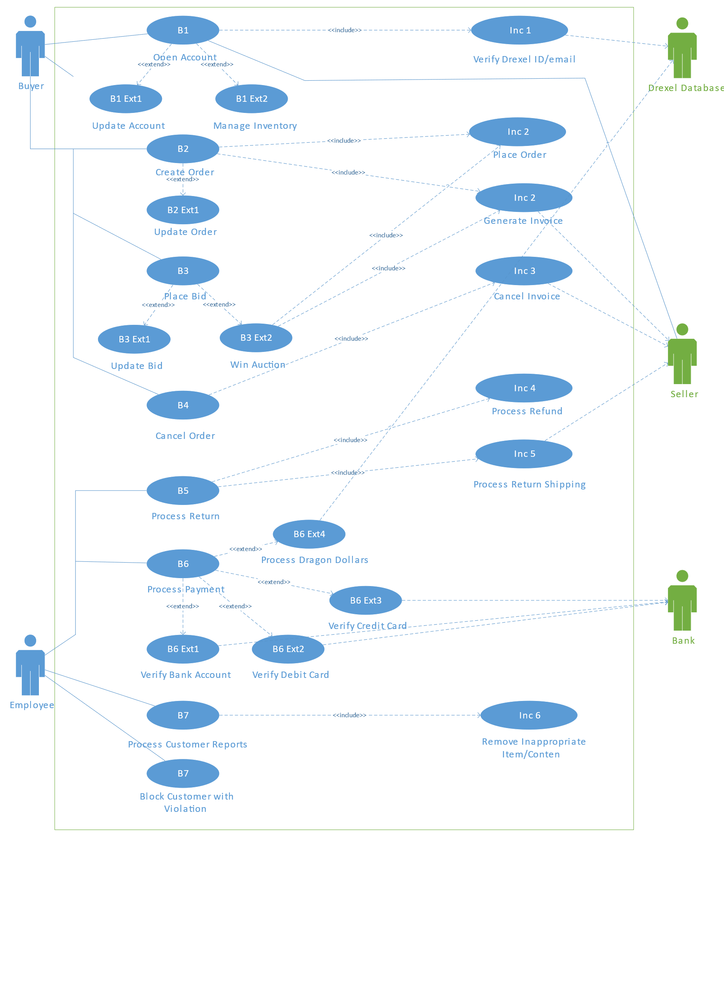

**INFO 620 Team Milestone Signoff Sheet**

**I certify that I have reviewed and approved each artifact of this assignment:**

**Signed:**

**Xiang Liu 02/02/2018**

**____________________________________________________**

**Xujian Zhang 02/02/2018**

**____________________________________________________**

**____________________________________________________**

**___________________________________________________**